Movie Ticket Booking System
Tables:
User Table:
CREATE TABLE Users (
user_id INT PRIMARY KEY,
name VARCHAR(100) NOT NULL,
email VARCHAR(100) UNIQUE,
phone VARCHAR(15)
);

INSERT INTO Users (user_id, name, email, phone) VALUES
(1, 'Rahul Sharma', 'rahul@gmail.com', '9876543210'),
(2, 'Priya Reddy', 'priya@gmail.com', '9876543211'),
(3, 'Arjun Kumar', NULL, '9876543212'),
(4, 'Sneha Patel', 'sneha@gmail.com', NULL),
(5, 'Vikram Singh', 'vikram@gmail.com', '9876543214'),
(6, 'Anjali Rao', 'anjali@gmail.com', NULL),
(7, 'Kiran Kumar', NULL, '9876543216'),
(8, 'Neha Gupta', 'neha@gmail.com', '9876543217'),
(9, 'Rohit Verma', 'rohit@gmail.com', NULL),
(10, 'Pooja Rani', 'pooja@gmail.com', '9876543219'),
(11, 'Suresh Babu', NULL, NULL),
(12, 'Divya Sharma', 'divya@gmail.com', '9876543221'),
(13, 'Manoj Reddy', 'manoj@gmail.com', '9876543222'),
(14, 'Kavya Singh', NULL, '9876543223'),
(15, 'Ajay Patel', 'ajay@gmail.com', NULL),
(16, 'Meena Rao', 'meena@gmail.com', '9876543225'),
(17, 'Naveen Kumar', NULL, NULL),
(18, 'Swathi Reddy', 'swathi@gmail.com', '9876543227'),
(19, 'Vijay Sharma', 'vijay@gmail.com', NULL),
(20, 'Lakshmi Devi', NULL, '9876543229');

select * from users;
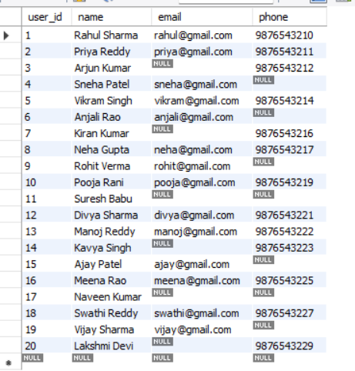
Movies Table:
CREATE TABLE Movies (
movie_id INT PRIMARY KEY,
movie_name VARCHAR(100) NOT NULL,
genre VARCHAR(50),
duration INT
);

INSERT INTO Movies (movie_id, movie_name, genre, duration) VALUES
(1, 'RRR', 'Action', 182),
(2, 'Baahubali', 'Action', 159),
(3, 'Pushpa', 'Action', 179),
(4, 'Arjun Reddy', 'Romance', 187),
(5, 'Jersey', 'Drama', NULL),
(6, 'Eega', 'Fantasy', 134),
(7, 'Ala Vaikunthapurramuloo', NULL, 165),
(8, 'Devara', 'Action', 178),
(9, 'Hi Nanna', 'Drama', 155),
(10, 'Sita Ramam', 'Romance', NULL),
(11, 'Dasara', 'Action', 156),
(12, 'Mahanati', 'Biography', 177),
(13, 'Agent', NULL, 156),
(14, 'Kushi', 'Romance', NULL),
(15, 'Salaar', 'Action', 175),
(16, 'Goodachari', 'Thriller', 147),
(17, 'Major', NULL, 149),
(18, 'Vikram', 'Action', 174),
(19, 'Leo', 'Thriller', NULL),
(20, 'Kantara', 'Drama', 148);
Select * from movies;
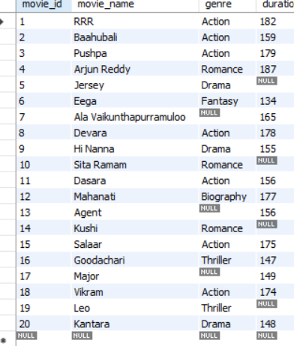
Theaters table:
CREATE TABLE Theaters (
theater_id INT PRIMARY KEY,
theater_name VARCHAR(100) NOT NULL,
location VARCHAR(100)
);

INSERT INTO Theaters (theater_id, theater_name, location) VALUES
(1, 'PVR Cinemas', 'Hyderabad'),
(2, 'INOX', 'Mumbai'),
(3, 'Cinepolis', 'Bangalore'),
(4, 'AMB Cinemas', 'Hyderabad'),
(5, 'Asian Cinemas', NULL),
(6, 'Miraj Cinemas', 'Pune'),
(7, 'Prasads Multiplex', 'Hyderabad'),
(8, 'Sathyam Cinemas', 'Chennai'),
(9, 'PVR Icon', NULL),
(10, 'INOX Megaplex', 'Delhi'),
(11, 'Carnival Cinemas', 'Kolkata'),
(12, 'Asian GPR Multiplex', 'Hyderabad'),
(13, 'Cinepolis Central', NULL),
(14, 'Mukta A2 Cinemas', 'Pune'),
(15, 'PVR Nexus', 'Bangalore'),
(16, 'Sudarshan 35MM', NULL),
(17, 'Sandhya Theatre', 'Hyderabad'),
(18, 'AAA Cinemas', 'Hyderabad'),
(19, 'INOX Forum', NULL),
(20, 'Vijayalakshmi Theatre', 'Warangal');
select * from theaters;
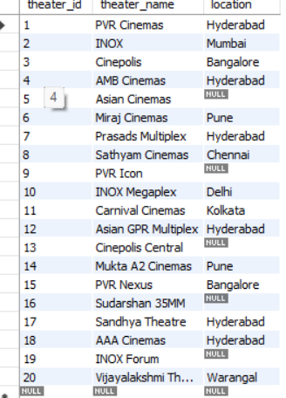
Shows Table:
CREATE TABLE Shows (
show_id INT PRIMARY KEY,
movie_id INT,
theater_id INT,
show_time DATETIME,
price DECIMAL(10,2),
FOREIGN KEY (movie_id) REFERENCES Movies(movie_id),
FOREIGN KEY (theater_id) REFERENCES Theaters(theater_id)
);

INSERT INTO Shows (show_id, movie_id, theater_id, show_time, price) VALUES
(1, 1, 1, '2026-09-04 10:00:00', 200.00),
(2, 2, 2, '2026-09-04 13:00:00', 250.00),
(3, 3, 3, '2026-09-04 16:00:00', 220.00),
(4, 4, 4, '2026-09-04 19:00:00', 300.00),
(5, 5, 5, '2026-09-04 21:30:00', NULL),
(6, 6, 6, '2026-09-05 10:30:00', 180.00),
(7, 7, 7, '2026-09-05 14:00:00', 250.00),
(8, 8, 8, NULL, 280.00),
(9, 9, 9, '2026-09-05 18:30:00', NULL),
(10, 10, 10, '2026-09-05 21:00:00', 320.00),
(11, 11, 11, '2026-09-06 11:00:00', 200.00),
(12, 12, 12, '2026-09-06 14:30:00', 230.00),
(13, 13, 13, '2026-09-06 17:30:00', NULL),
(14, 14, 14, '2026-09-06 20:30:00', 280.00),
(15, 15, 15, NULL, 350.00),
(16, 16, 16, '2026-09-07 12:00:00', 190.00),
(17, 17, 17, '2026-09-07 15:30:00', NULL),
(18, 18, 18, '2026-09-07 18:00:00', 300.00),
(19, 19, 19, '2026-09-07 21:00:00', 330.00),
(20, 20, 20, '2026-09-08 19:30:00', NULL);
Select * from shows:
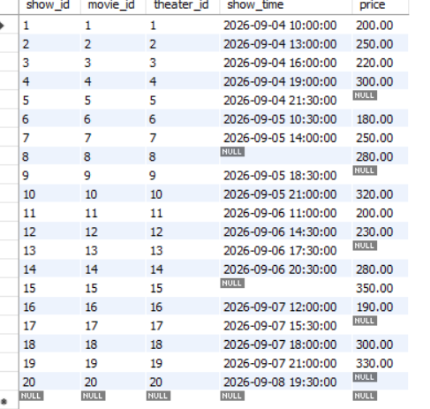
Booking Table:
CREATE TABLE Bookings (
booking_id INT PRIMARY KEY,
user_id INT,
show_id INT,
seats INT,
total_amount DECIMAL(10,2),
booking_date DATE,
FOREIGN KEY (user_id) REFERENCES Users(user_id),
FOREIGN KEY (show_id) REFERENCES Shows(show_id)
);
INSERT INTO Bookings
(booking_id, user_id, show_id, seats, total_amount, booking_date)
VALUES
(1, 1, 1, 2, 400.00, '2026-09-01'),
(2, 2, 2, 3, 750.00, '2026-09-01'),
(3, 3, 3, 1, 220.00, '2026-09-02'),
(4, 4, 4, 4, 1200.00, '2026-09-02'),
(5, 5, 5, 2, NULL, '2026-09-02'),
(6, 6, 6, 3, 540.00, '2026-09-03'),
(7, 7, 7, 2, 500.00, NULL),
(8, 8, 8, 5, 1400.00, '2026-09-03'),
(9, 9, 9, 1, NULL, '2026-09-04'),
(10, 10, 10, 2, 640.00, '2026-09-04'),
(11, 11, 11, 3, 600.00, '2026-09-04'),
(12, 12, 12, 2, 460.00, '2026-09-05'),
(13, 13, 13, 4, NULL, '2026-09-05'),
(14, 14, 14, 2, 560.00, NULL),
(15, 15, 15, 3, 1050.00, '2026-09-06'),
(16, 16, 16, 1, 190.00, '2026-09-06'),
(17, 17, 17, 2, NULL, '2026-09-07'),
(18, 18, 18, 4, 1200.00, '2026-09-07'),
(19, 19, 19, 2, 660.00, '2026-09-08'),
(20, 20, 20, 3, NULL, '2026-09-08');
Select * from bookings;
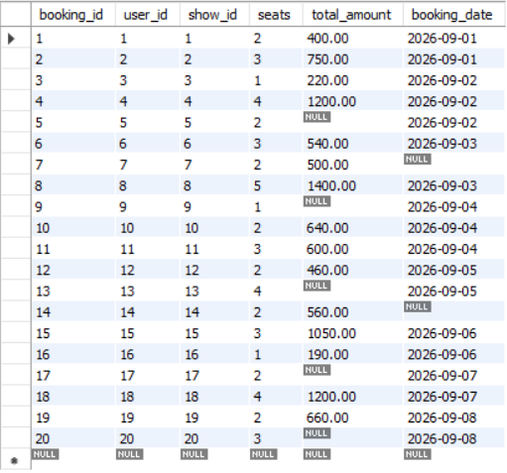

Basic Queries
- Display movies longer than 2 hours
select * from movies where duration >160;
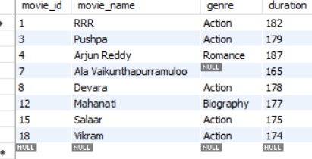
- Show users with Gmail accounts
select * from users where email is not null;
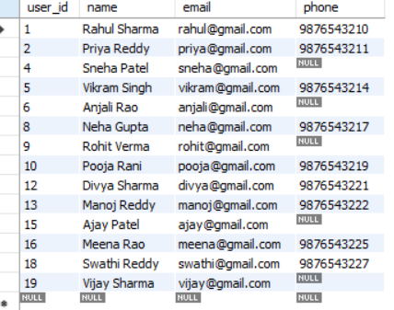
- List shows after current date
select * from shows where date(show_time) >curdate();
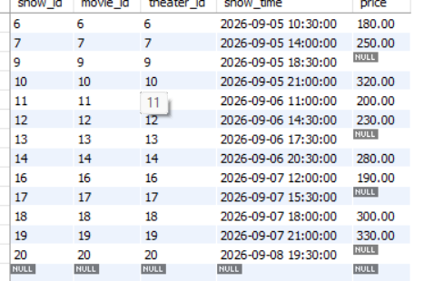

- Display theaters in a specific location
select * from theaters where location ="hyderabad";
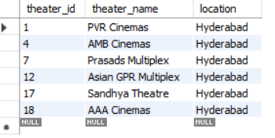

Joins
- Show user names with their bookings
select u.name, b.booking_id, b.seats,b.total_amount from users u join Bookings b on u.user_id = b.user_id;
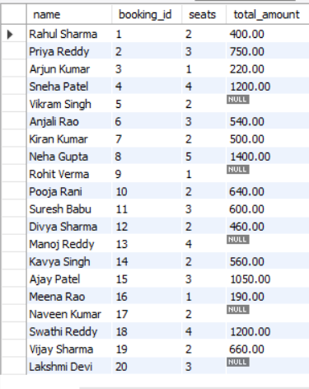
- Display movie names with show timings
select m.movie_name,s.show_time from movies m right join shows s on m.movie_id=s.movie_id;
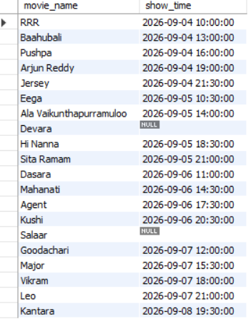
- Show booking details with user and movie
select u.name,m.movie_name,b.seats,b.total_amount from bookings b join shows s on b.show_id=s.show_id join movies m on s.movie_id=m.movie_id join users u on b.user_id=u.user_id where b.total_amount is not null;
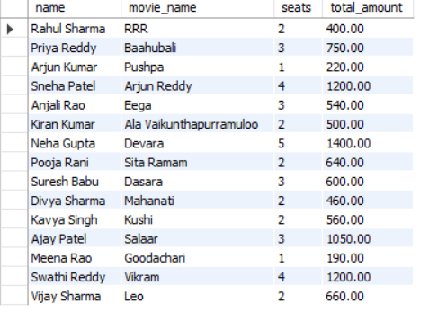
Aggregate
- Count total movies
select count(*) as total_movies from movies;


- Find average ticket price
select avg(price) as avg_ticaket_price from shows;
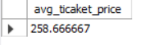
- Calculate total booking revenue
select max(price) as max_price from shows;
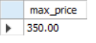
Subqueries
- Find users who never booked tickets
select * from users where user_id not in(select user_id from bookings);
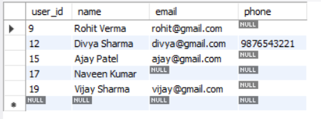
- Show shows with price above average
select * from shows where price >(select avg(price) from shows);
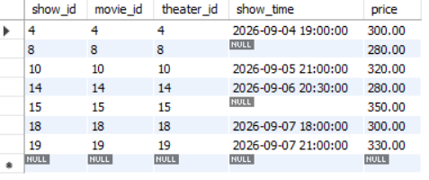
- Find movies not booked
select * from movies where movie_id not in( select s.movie_id from bookings b join shows s on b.show_id=s.show_id);
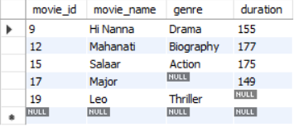

Updates & Deletes
- Update movie duration
update movies set duration= 200 where movie_id in(2,4,6);
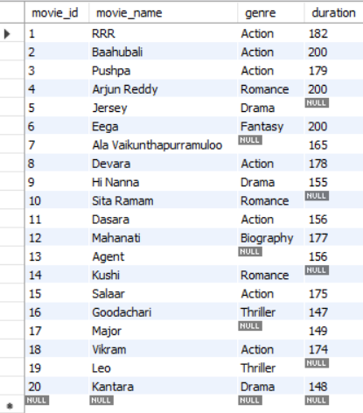
- Change user email
update users set email="arjun980@gmail.com" where user_id=3;
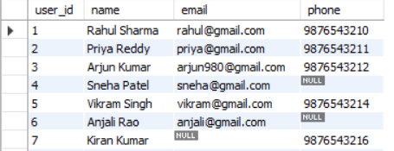
- Delete empty bookings
delete from bookings where total_amount is null;
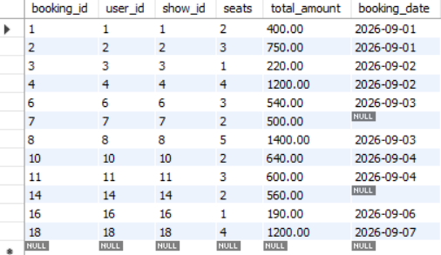
Views
- Create view for booking details
create view booking_detalies as select u.name,m.movie_name,s.show_time,b.seats,b.total_amount from bookings b join shows s on b.show_id=s.show_id join movies m on s.movie_id=m.movie_id join users u on b.user_id=u.user_id;
select * from booking_detalies;
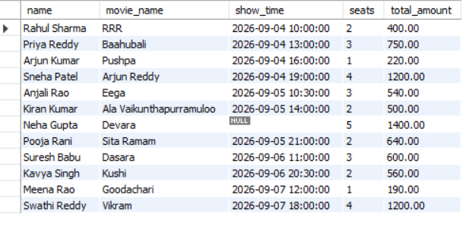
- Create view for movie shows
create view movie_detalies as
select s.show_id ,m.movie_name ,t.theater_name,s.show_time,b.total_amount from bookings b join shows s on b.show_id=s.show_id
join movies m on s.movie_id=m.movie_id join theaters t on s.theater_id=t.theater_id;
select * from movie_detalies;
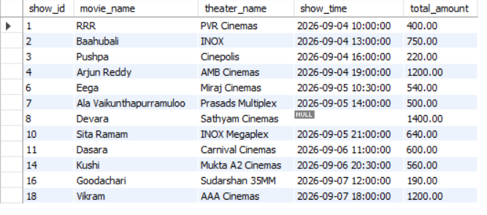

Stored Procedures
1. Insert a New User
Create a stored procedure to insert a new user.
The procedure should accept:
- name
- email
- Phone
delimiter //
create procedure insert_date(i int,n varchar(20),e varchar(20), p bigint)
begin
insert into users (user_id ,name ,email,phone) values(i,n,e,p);
end //
delimiter ;
call insert_date(21,"sai","sai@gmail.com",7893485616);

select * from users;
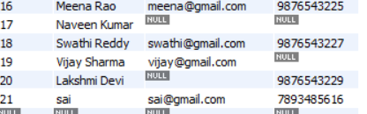
2. Update Ticket Price
Create a stored procedure to update ticket price.
Pass:
- show_id
- new_price
delimiter @@
create procedure update_show(s int,p int)
begin
update shows set price=p where show_id=s;
end @@
delimiter ;
call update_show(12,210);
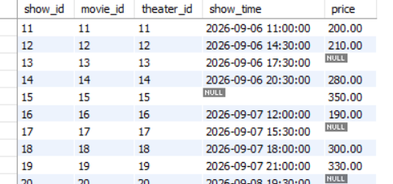
3. Display Bookings of a User
Create a stored procedure to display all bookings of a user.
Pass:
- user_id
delimiter //
create procedure user_show(u int)
begin
select u.user_id,u.name,m.movie_name,s.show_time,b.seats,t.theater_name ,b.total_amount from bookings b join shows s on b.show_id=s.show_id join movies m
on s.movie_id=m.movie_id join theaters t on s.theater_id=t.theater_id join users u on b.user_id=u.user_id where u.user_id=u;
end //
delimiter ;
call user_show(3);
4. Calculate Total Revenue
Create a stored procedure to calculate total revenue.
The procedure should return:
Total revenue from Bookings table.

delimiter %%
create procedure total_revenu( out total int )
begin
select sum(total_amount) into total from bookings;
end %%
delimiter ;
call total_revenu(@total);
select @total;
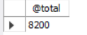
5. List Shows of a Movie
Create a stored procedure to list shows of a movie.
Pass:
- movie_id
Display:
All shows of that movie.
delimiter &&
create procedure movie_shows(in m int)
begin
select * from shows where movie_id=m;
end &&
delimiter ;
call movie_shows(3);
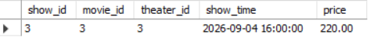

Reports / Analysis
- Top 5 most booked movies
select m.movie_name ,count(m.movie_name) as total from bookings b join shows s on b.show_id=s.show_id join movies m on s.movie_id=m.movie_id
group by m.movie_name order by total desc limit 5;
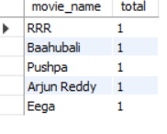
- Most active users (users with highest bookings)
select u.name,count(b.booking_id) as hight_bookings from bookings b join users U on b.user_id =u.user_id group by u.user_id order by hight_bookings desc;
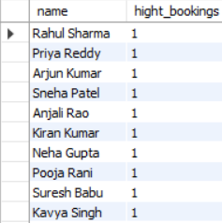
- Monthly booking report
select date_format(booking_date,"%Y-%m")as months, count(booking_id) as total_bookings from bookings group by months;
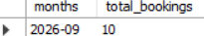
- Movie generating highest revenue
select m.movie_name, sum(b.total_amount) as total_revenu from bookings b join shows s on b.show_id=s.show_id join movies m on s.movie_id = m.movie_id
group by m.movie_name order by total_revenu desc limit 1;


- User spending analysis
select u.user_id,u.name, sum(b.total_amount) as total_amount from bookings b join users u on b.user_id=u.user_id group by u.user_id order by total_amount desc;
